**A survey on researchers' attitudes and practices towards Open Science**

**Abstract**

**Introduction**

Openness and transparency are at the heart of maintaining the credibility of scientific research and guaranteeing the valid and ethical dissemination of its results. However, most researchers encounter difficulties in applying for access to data from published studies[1], and even when journals demand disclosure or sharing of raw data, researchers often do not put this into practice[2, 3]. The reasons for rejecting academic transparency and sharing can be complex, and issues involving research integrity are among those that raise concerns. The Research integrity issues encompass deliberate misconduct, such as fabrication, falsification, plagiarism, and questionable research practices [4], that undermine the value of research and has implications for the authority of science [5]. Replication of existing studies is the cornerstone of verifying the reliability and credibility of empirical findings [6], but a series of repeatability crises since 2010 [7, 8] involving a range of researchers and disciplines [9-11] have destabilized the public's confidence in research [12]. A number of scholars have explained the problem, as we can justify this situation by the principle of statistics itself. Statistical tests to test hypotheses naturally lead to the conclusion that independent studies are only "highly probable" to disprove the null hypothesis [13]. Studies with low statistical power may also be the causal factor for multiple inconsistent results [14, 15]. Thus, failure to replicate cannot be attributed in a generalized way to questionable research practices.

However, it is still important to realize that academic integrity issues are objective issue. More unethical deliberate misconduct is less common [16, 17]. But meta-analyses show that the proportion of self-reported questionable research practice exceeds 10%, and the number of claimed witnesses of questionable research practice behaviour is even higher [17, 18]. Bibliometric studies show that academics are concerned about the prevalence and severity of questionable research practices [19]. The reasons for p-hacking, resampling, and other behaviours are complex. They may range from career advancement pressures on the researcher because positive results are more likely to be published [20, 21], as well as the loss of ethical boundaries caused by workplace stress[22]. However, changing the overall academic environment is extremely difficult.

Regulating misconduct in the research process through open science practices may be an effective solution, with measures such as pre-registration and open data and code [23] helping to expose opaque grey practices in the research process. Opening up methods, materials and data to reduce deliberate or unintentional questionable research practices at the author level is one of the aims of open scientific practice [24], and these measures have been met with a high level of acceptance and engagement [25]. China currently has the largest group of scholars, and the issue of academic integrity is one that has been plaguing Chinese academics to improve their influence [26, 27]. Meanwhile, open science practice is still in the early stages of development in China. Therefore, a study of the current academic practices of Chinese scholars will provide a reference for the promotion and facilitation of open science in the future.

The extent to which open science practices have reduced questionable research practices is worth exploring, while whether open science practices have influenced researcher perceptions and prompted a shift from questionable research practices to responsible research practices is also a concern of this study. We conduct a cross-sectional study to understand this better and draw conclusions about the author-level impact of open science practices.

**Method**

**Sample**

This research includes a broad group of researchers in China and Nigeria. It encompasses early career researchers, such as undergraduate, postgraduate, and PhD students, and senior career researchers who are already in faculty positions or have titles, such as lecturers, professors, and institute researchers. For the sample collection in China, we distributed the questionnaire by sending QR code posters to academic communities and institutes (figure 1) and mass emails to university employees. Mass mailing is done by Python by coding the colleges to get the object's email address and automatically sending the edited email. The relevant code is shown in Appendix A. By distributing the questionnaires in a variety of ways as described above, we were able to guarantee the diversity of participants and sample size. Our Nigerian national co-author (J Caleb) helped distribute the English version of the questionnaire to Nigerian scholars. The Chinese and English versions of the questionnaire can be downloaded from Appendix B.

**Table 1 Academic communities where the questionnaire was distributed and the delivery pathway.**

|  |  |
| --- | --- |
| **Questionnaire distribution** | **Distribution pathway** |
| Chinese Open Science Network | WeChat Official Platform |
| Institute of Psychology, CAS | WeChat Official Platform |
| ChinaXiv | WeChat Official Platform |
| 52Brain | WeChat Official Platform |

We distributed QR code posters from 25 January to 20 February 2024, and the first round of email mass mailing was conducted on 20 February 2024, with 25 February as the cut-off point for email responses. A total of 1,700 emails were distributed to various universities in China. Data collection in Nigeria was conducted on 2 March 2024. To encourage researchers to complete the questionnaire and to avoid selection bias resulting from direct financial rewards, we made a public benefit donation to encourage responses for questionnaire distribution in China. The corresponding author will make a donation of 0.5 Yuan on behalf of each participant who provides a valid questionnaire to the foundation for social welfare programs hosted by Tencent Enterprises in China.

**Questionnaire design**

The questionnaire for this study was divided into three main modules, the first of which examined the researcher's perceptions, subjective attitudes, willingness to practice, and barriers to practice of the eight types of open science practices. Each question began with a brief introduction to the topic area and definitions of key terms (figure 2). Awareness of the practices was simply achieved by asking the researcher if they were known or had performed one or multiple open science practices. Subjective attitudes were taken on a five-point Likert scale (1-strongly oppose, 2-oppose, 3-neutral, 4-agree, 5-strongly agree) to measure the researcher's attitudes towards open science practices. Willingness to practice was similarly examined indirectly on a five-point Likert scale by asking the authors whether they would engage in or perform open science practices in the future. Barriers to practice ask the researcher what influences the motivation to carry out a particular practice, and the answers include types such as sensitive information, policy restrictions, hardware and software limitations, and interpersonal relationships.

**Table 2 The main type of open science practice.**

|  |  |
| --- | --- |
| **Open Science Practice** |  |
| Study Preregistration | Registration of the research proposal on an open platform before the research is conducted. |
| Registered Reports | Format of empirical article where a study proposal is reviewed before the research is undertaken. |
| Replication Studies | Research attempting to reproduce the methods and findings of prior research. |
| Open Data | Making research data publicly available, e.g FAIR data. |
| Open Code | Making analysis code publicly available. |
| Preprints | Making research papers available before journal peer-review in an online repository. |
| Open Access Publication | Making peer-reviewed papers or other publications publicly available. |
| Open Peer Review | Journal or grant peer review where authors and reviewers are aware of each other's identity |

The second module examined questionable research practices and referenced Bakker's research design. It focused on self-reporting, disclosure, and acceptance of questionable research practices during the research career. Self-report was answered with a yes or no response, and disclosure of the situation around the person was answered with a percentage such as "How many people around you do you think to engage in these behaviours?". Acceptance was measured on a three-point scale.

The final module collects basic participant characteristic information and contains attention detection and open-response questions.

**Analysis Method**

Data were analysed using R version 4.4.1 software. Most of our analyses were descriptive, examining the distribution of responses to individual questions about each practice and the overall distribution of participants. Subgroup analyses were conducted based on participant characteristic variables of interest to examine associations between variables. T-tests assessed differences between groups.

**Result**

A total of 610 questionnaires completed by the Chinese researchers were recovered; 199 were valid, with a validity rate of 32.6 %. A total of 1,700 questionnaires were sent by mail, with a response rate of about 10 %. Regarding the Nigerian data, 557 questionnaires were returned, and 173 were valid, with a validity rate of 31.1 %.

**Basic characteristics of participants**

The Chinese researcher sample's distribution of research career stages is greatly dominated by Masters and Ph. Ds, accounting for 61.8%, along with about a quarter of lecturers, associate professors, and professors. The discipline distribution of the Chinese participants mainly was psychology and medical management, with psychology accounting for 61.3%. This may be related to our distribution method, in which we prioritised researchers in psychology during the email distribution. The distribution of the research career stages of the Nigerian participants was dominated by postgraduate and undergraduate students, with 63 % and 14.5 %, respectively. Regarding disciplines, Nigerian participants varied significantly from China, with 38.2 % concentrated in the sciences, 15.6 % in medicine and health, and a more balanced distribution in other disciplines. Diagrams of the basic information can be obtained in Appendix A.

**Open Science Practice**

We investigated Chinese researchers' awareness of open science practices (Figure 1), and the majority of scholars had a certain level of knowledge about open science practices, with open data and open access publication having the highest awareness rates, while only 101 researchers were aware of registration reports. Also due to the high percentage of researchers in the discipline of psychology, we quantified the weight of psychology in this (Figure 2).

**Figure 1 Number of Chinese researchers aware of open science practices**

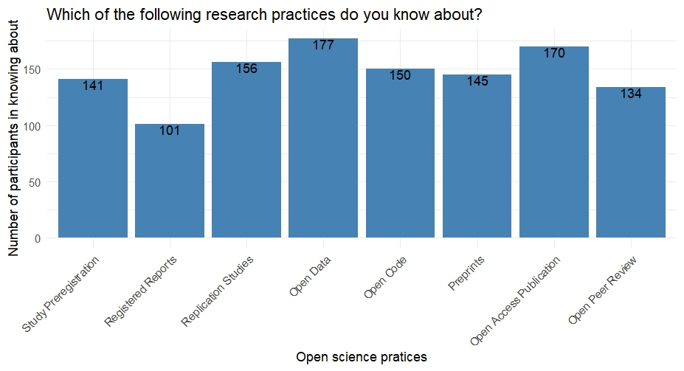

**Figure 2 Percentage of awareness of open science practices and proportion of researchers in psychology.**

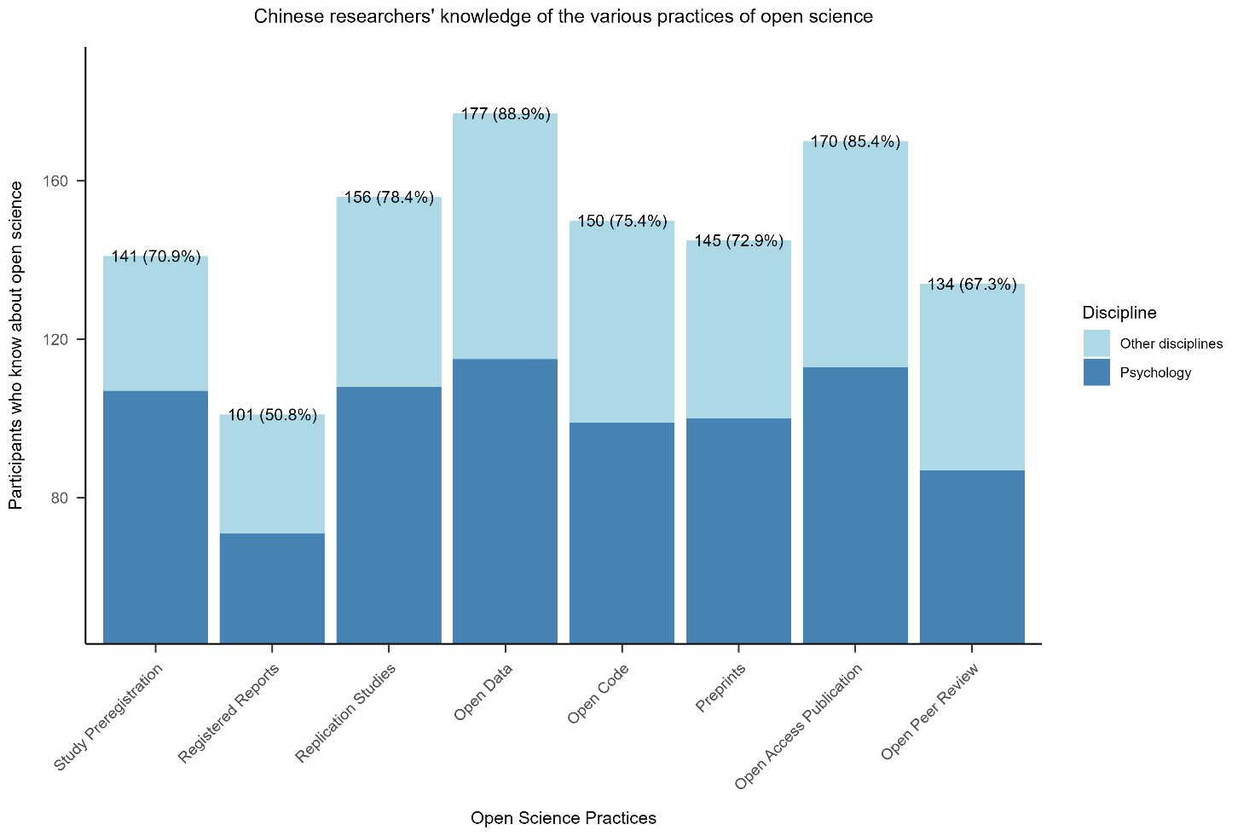

Participants were asked about their attitudes towards open science practice and whether they intended to undertake any open science practice in the future.

**Figure 3** **Chinese researchers' attitudes towards various open science practices**

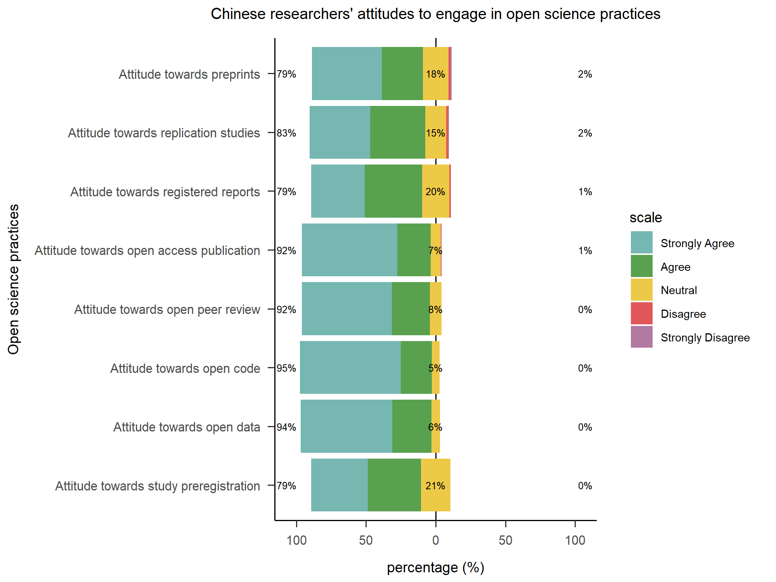

**Figure 4 The willingness of Chinese participants to undertake or engage in open science practices in the future**

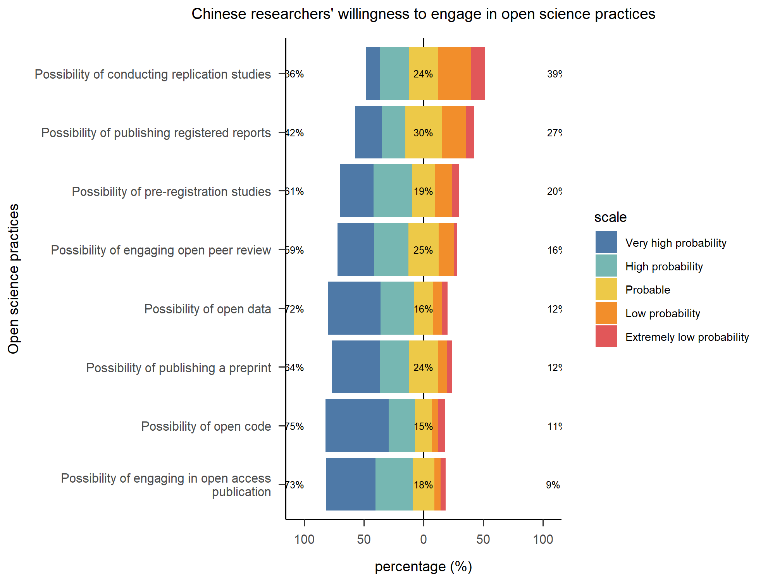

Chinese researchers generally supported the open science practices covered in our questionnaire, agreeing that they should be implemented or enforced in academic contexts, with a support rate of 79% or more. Support for preprints, replication studies, and registered reports was slightly lower than the other practices. This corresponds to whether they intend to carry out a particular open science practice in the future, as shown in Figure 2, where 27% of the researchers consider themselves less likely to conduct a replication study. And clearly there was a significant increase in the number of researchers who were ambivalent when asked if they intended to undertake an open science practice.

**Figure 5 Nigeria researchers' attitudes towards various open science practices**

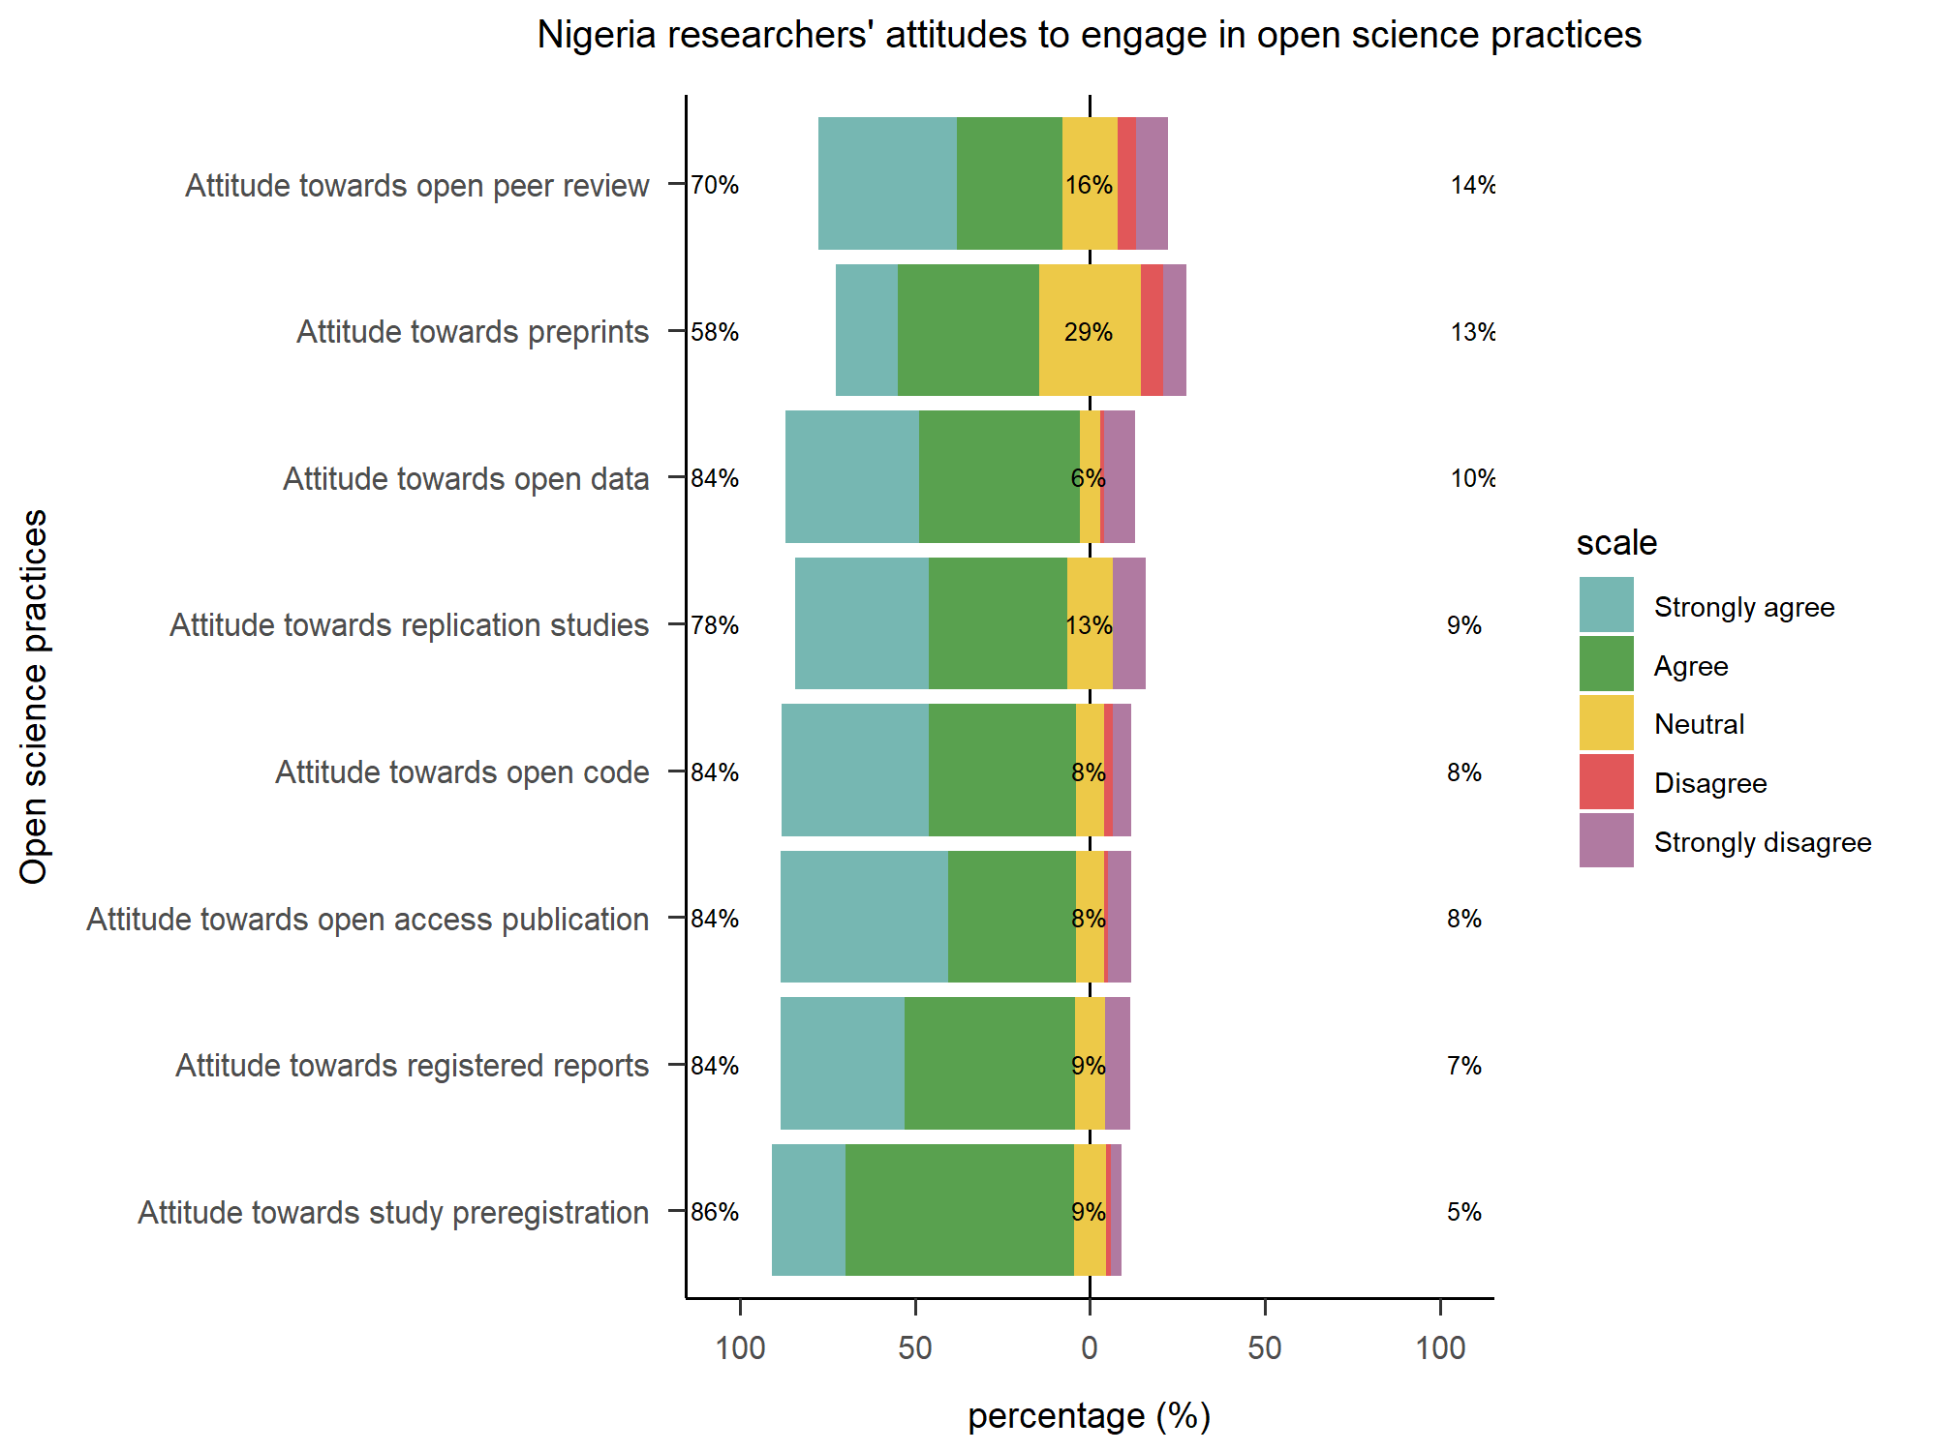

**Figure 6 The willingness of Chinese participants to undertake or engage in open science practices in the future**

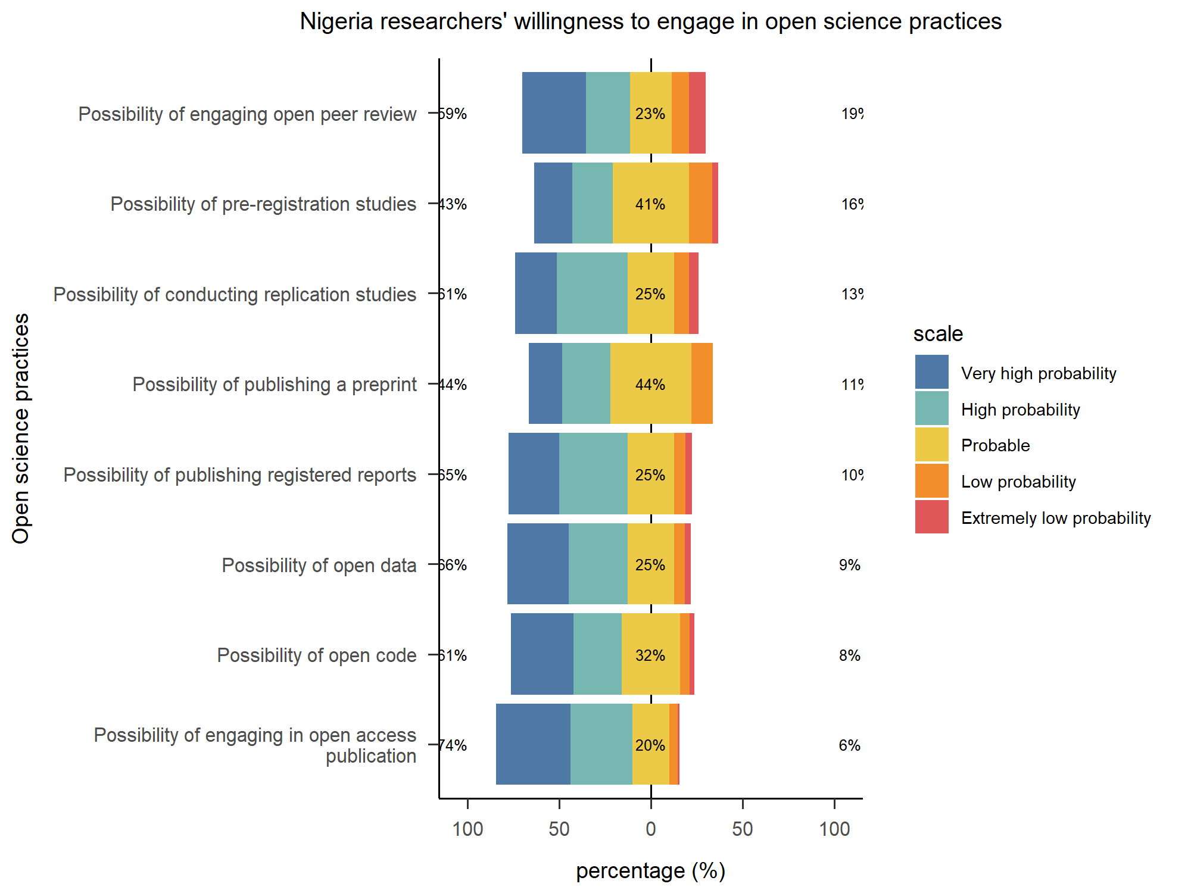

In terms of attitudes towards open science practices, the difference with Chinese researchers is that there are more Nigerian researchers who strongly disagree with open science practices, despite the fact that overall, those who disagree remain in the minority. In the question on intention towards open science practices, the overall bias remains towards being willing to engage in one or more open science practices in the future.

**Questionable research practices**

**Reference**

[1] J. M. Wicherts, D. Borsboom, J. Kats, and D. Molenaar, "The poor availability of psychological research data for reanalysis," (in eng), *Am Psychol,* vol. 61, no. 7, pp. 726-8, Oct 2006, doi: 10.1037/0003-066x.61.7.726.

[2] C. J. Savage and A. J. Vickers, "Empirical study of data sharing by authors publishing in PLoS journals," (in eng), *PLoS One,* vol. 4, no. 9, p. e7078, Sep 18 2009, doi: 10.1371/journal.pone.0007078.

[3] C. Vogeli *et al.*, "Data withholding and the next generation of scientists: results of a national survey," (in eng), *Acad Med,* vol. 81, no. 2, pp. 128-36, Feb 2006, doi: 10.1097/00001888-200602000-00007.

[4] N. H. Steneck, "Fostering integrity in research: Definitions, current knowledge, and future directions," *Science and Engineering Ethics,* vol. 12, no. 1, pp. 53-74, 2006/03/01 2006, doi: 10.1007/PL00022268.

[5] I. Vermeulen and T. Hartmann, "Questionable research and publication practices in communication science," vol. 9, ed: Taylor & Francis, 2015, pp. 189-192.

[6] S. Schmidt, "Shall we Really do it Again? The Powerful Concept of Replication is Neglected in the Social Sciences," *Review of General Psychology,* vol. 13, no. 2, pp. 90-100, 2009, doi: 10.1037/a0015108.

[7] S. Doyen, O. Klein, C.-L. Pichon, and A. Cleeremans, "Behavioral Priming: It's All in the Mind, but Whose Mind?," *PLOS ONE,* vol. 7, no. 1, p. e29081, 2012, doi: 10.1371/journal.pone.0029081.

[8] E.-J. Wagenmakers, R. Wetzels, D. Borsboom, and H. L. J. van der Maas, "Why psychologists must change the way they analyze their data: The case of psi: Comment on Bem (2011)," *Journal of Personality and Social Psychology,* vol. 100, no. 3, pp. 426-432, 2011, doi: 10.1037/a0022790.

[9] M. Baker, "1,500 scientists lift the lid on reproducibility," *Nature,* vol. 533, no. 7604, pp. 452-454, 2016/05/01 2016, doi: 10.1038/533452a.

[10] C. F. Camerer *et al.*, "Evaluating the replicability of social science experiments in Nature and Science between 2010 and 2015. Nature Human Behaviour, 2, 637-644," ed, 2018.

[11] C. G. Begley and J. P. Ioannidis, "Reproducibility in science: improving the standard for basic and preclinical research," *Circ Res,* vol. 116, no. 1, pp. 116-126, 2015.

[12] H. Pashler and E. J. Wagenmakers, "Editors’ Introduction to the Special Section on Replicability in Psychological Science:A Crisis of Confidence?," *Perspectives on Psychological Science,* vol. 7, no. 6, pp. 528-530, 2012, doi: 10.1177/1745691612465253.

[13] D. J. Benjamin *et al.*, "Redefine statistical significance. Nature Human Behaviour, 2, 6-10," ed, 2018.

[14] T. D. Stanley, E. C. Carter, and H. Doucouliagos, "What meta-analyses reveal about the replicability of psychological research," *Psychol Bull,* vol. 144, no. 12, p. 1325, 2018.

[15] H. Pashler and C. R. Harris, "Is the Replicability Crisis Overblown? Three Arguments Examined," *Perspectives on Psychological Science,* vol. 7, no. 6, pp. 531-536, 2012, doi: 10.1177/1745691612463401.

[16] J. M. DuBois *et al.*, "Understanding Research Misconduct: A Comparative Analysis of 120 Cases of Professional Wrongdoing," *Account Res,* vol. 20, no. 5-6, pp. 320-338, 2013/09/03 2013, doi: 10.1080/08989621.2013.822248.

[17] V. Pupovac and D. Fanelli, "Scientists admitting to plagiarism: a meta-analysis of surveys," *Science and engineering ethics,* vol. 21, pp. 1331-1352, 2015.

[18] Y. Xie, K. Wang, and Y. Kong, "Prevalence of Research Misconduct and Questionable Research Practices: A Systematic Review and Meta-Analysis," *Science and Engineering Ethics,* vol. 27, no. 4, p. 41, 2021/06/29 2021, doi: 10.1007/s11948-021-00314-9.

[19] M. J. Y. Neoh, A. Carollo, A. Lee, and G. Esposito, "Fifty years of research on questionable research practises in science: quantitative analysis of co-citation patterns," *Royal Society Open Science,* vol. 10, no. 10, p. 230677, 2023, doi: doi:10.1098/rsos.230677.

[20] B. A. Nosek, J. R. Spies, and M. Motyl, "Scientific utopia: II. Restructuring incentives and practices to promote truth over publishability," *Perspectives on Psychological Science,* vol. 7, no. 6, pp. 615-631, 2012.

[21] N. S. Young, J. P. A. Ioannidis, and O. Al-Ubaydli, "Why current publication practices may distort science," *PLoS medicine,* vol. 5, no. 10, p. e201, 2008.

[22] M. D. Mumford *et al.*, "Validation of ethical decision making measures: Evidence for a new set of measures," *Ethics & Behavior,* vol. 16, no. 4, pp. 319-345, 2006.

[23] P. Murray-Rust, "Open Data in Science," *Nature Precedings,* 2008/01/18 2008, doi: 10.1038/npre.2008.1526.1.

[24] M. S. Hagger, "Embracing Open Science and Transparency in Health Psychology," *Health psychol,* vol. 13, no. 2, pp. 131-136, 2019/04/03 2019, doi: 10.1080/17437199.2019.1605614.

[25] G. Christensen *et al.*, "Open science practices are on the rise: The state of social science (3S) survey," 2020.

[26] N. Yi, B. Nemery, and K. Dierickx, "How do Chinese universities address research integrity and misconduct? A review of university documents," *Developing World Bioethics,* vol. 19, no. 2, pp. 64-75, 2019, doi: <https://doi.org/10.1111/dewb.12231>.

[27] S. Chen and B. Macfarlane, "Academic integrity in China," *Handbook of academic integrity,* pp. 99-105, 2016.